CREATE JAVA APPLICATION

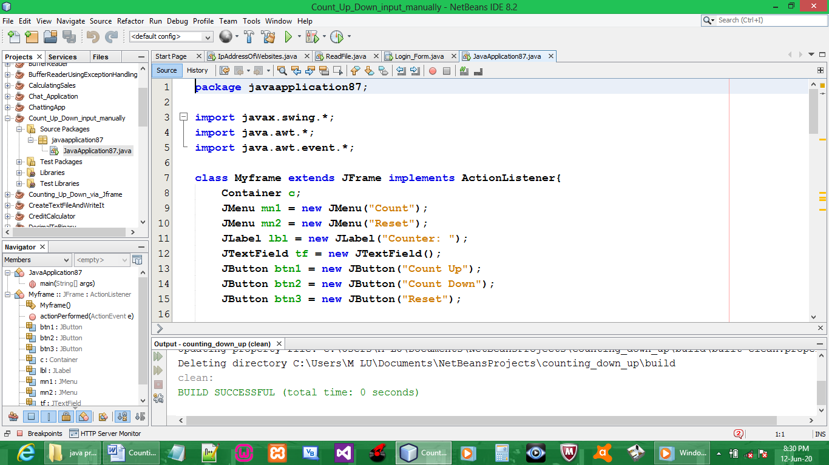

CODE:

package javaapplication87;

import javax.swing.*;
import java.awt.*;
import java.awt.event.*;

class Myframe extends JFrame implements ActionListener{
Container c;
JMenu mn1 = new JMenu("Count");
JMenu mn2 = new JMenu("Reset");
JLabel lbl = new JLabel("Counter: ");
JTextField tf = new JTextField();
JButton btn1 = new JButton("Count Up");
JButton btn2 = new JButton("Count Down");
JButton btn3 = new JButton("Reset");

Myframe(){
c =this.getContentPane();
c.setLayout(null);
c.setBackground(Color.red);
mn1.setBounds(2,10,90,30);
mn2.setBounds(110,10,90,30);

lbl.setBounds(23,110,90,30);
tf.setBounds(100,100,100,50);
btn1.setBounds(210,100,100,50);
btn2.setBounds(320,100,110,50);
btn3.setBounds(438,100,100,50);

c.add(mn1);
c.add(mn2);
c.add(lbl);
c.add(tf);
c.add(btn1);
c.add(btn2);
c.add(btn3);

btn1.addActionListener(this);
btn2.addActionListener(this);
btn3.addActionListener(this);
}

public int x;
public void actionPerformed(ActionEvent e){
if (e.getSource() == btn1){
x++;
tf.setText(Integer.toString(x));
}
if (e.getSource() == btn2){
x--;
tf.setText(Integer.toString(x));
}
if (e.getSource() == btn3){
x = 0;
tf.setText(String.valueOf(x));
}
}

}

public class JavaApplication87 {

public static void main(String[] args) {

Myframe f = new Myframe();
f.setTitle("Action Test");
f.setSize(500,300);
f.setLocation(100,100);
f.setVisible(true);
f.setDefaultCloseOperation(JFrame.EXIT_ON_CLOSE);

}

}

OUTPUT:

